**Kubernates**

Kubernetes (also known as "K8s") is an open-source container orchestration system that automates the deployment, scaling, and management of containerized applications

Kubernetes provides a platform-agnostic way to manage containerized applications, and can be run on a variety of platforms, including on-premises data centers, public cloud providers (such as AWS, Google Cloud Platform, and Microsoft Azure), and hybrid cloud environments.

**1.Use of kubernates:**

Kubernetes is primarily used for container orchestration, which means it helps manage and automate the deployment, scaling, and management of containerized applications. Containers are lightweight, portable, and efficient ways of packaging applications and their dependencies, and Kubernetes provides a platform-agnostic way to manage and deploy them across different environments.

some specific use cases for Kubernetes:

1. Application deployment: Kubernetes allows you to deploy your containerized applications to production environments with ease, using automated deployment strategies that ensure high availability and reliability.
2. Scaling and load balancing: Kubernetes can automatically scale your applications up or down based on demand, and it also provides built-in load balancing to distribute traffic evenly across containers.

**2.Why we use kubernates?**

for managing their containerized applications

Scalability: Kubernetes enables organizations to easily scale their applications up or down, based on demand.

Automation: Kubernetes automates many of the tasks involved in deploying and managing containerized applications, such as scheduling and monitoring

Security: Kubernetes provides several features for securing containerized applications, such as network isolation.

Overall, Kubernetes provides a powerful and flexible platform for managing containerized applications at scale, helping organizations achieve greater agility, scalability, and reliability in their software deployments.

**3.How to use?**

Using Kubernetes involves steps, including:

1. Installing Kubernetes: To use Kubernetes, you need to install it on your infrastructure. This involves setting up a Kubernetes cluster, which is a set of nodes that run Kubernetes and provide the computing resources needed to run containerized applications. Kubernetes can be installed on-premises or in the cloud, depending on your needs.
2. Creating a container image: Before you can deploy an application on Kubernetes, you need to create a container image that contains your application and its dependencies. This can be done using Docker or another containerization tool.
3. Creating a deployment: Once you have a container image, you can create a deployment in Kubernetes. A deployment is a Kubernetes object that manages the creation and scaling of your application's containers.
4. **Kubernates architecture:**

Kubernetes has a distributed architecture that is designed to provide scalability, reliability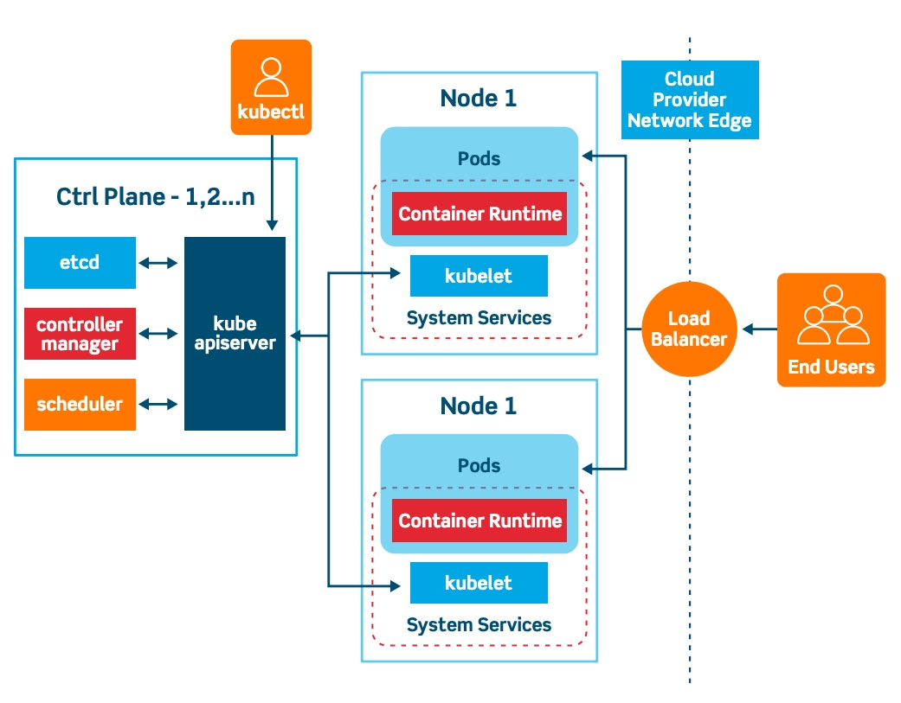

Kubernetes has a distributed architecture that is designed to provide scalability, reliability.

1. Master node: The master node is the control plane of the Kubernetes cluster, which is responsible for managing the overall state of the cluster. It runs several key components, including the API server, the etcd data store, and the controller manager.
2. API server: The API server is the central component of the Kubernetes control plane, which provides an API that clients can use to interact with the cluster. It validates and processes requests, and communicates with other components to execute them.
3. etcd: etcd is a distributed key-value store that stores the configuration data and state of the Kubernetes cluster. It serves as the primary data store for Kubernetes, and is used by other components to read and write data.
4. Worker nodes: Worker nodes are the compute nodes in the Kubernetes cluster, which run the containerized applications.

